Algorithms & complexity

Lab: heap

Please insert the given sequence of keys into the heap of the specified type (max / min) and then remove all keys from it.

Heap type:

|  |
| --- |
| Max Heap |

Key sequence:

|  |  |  |  |  |  |  |  |
| --- | --- | --- | --- | --- | --- | --- | --- |
| 7 | 63 | 59 | 10 | 90 | 99 |  |  |

# Inserting into a heap

Draw a heap after inserting each key (draw it on a piece of paper, take a photo and paste it into the document).

For the last key to be inserted, draw a heap after completing each step while inserting the key - after each change of the heap structure (e.g. swapping two keys).

## Heap after inserting the keys (except the last one):

<place to paste a photo>

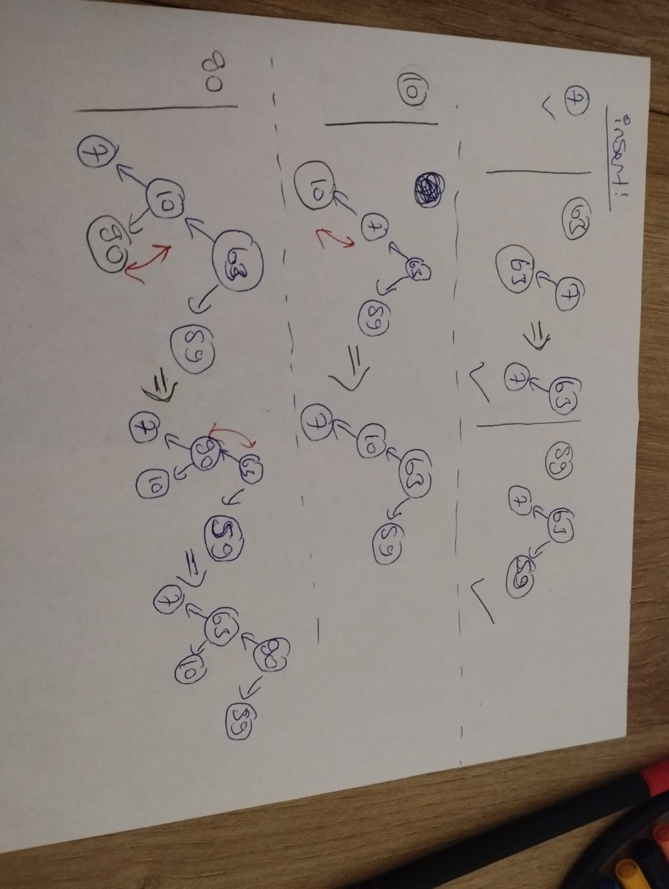

## Heap after inserting the last key (draw a heap after completing each step while inserting):

<place to paste a photo>

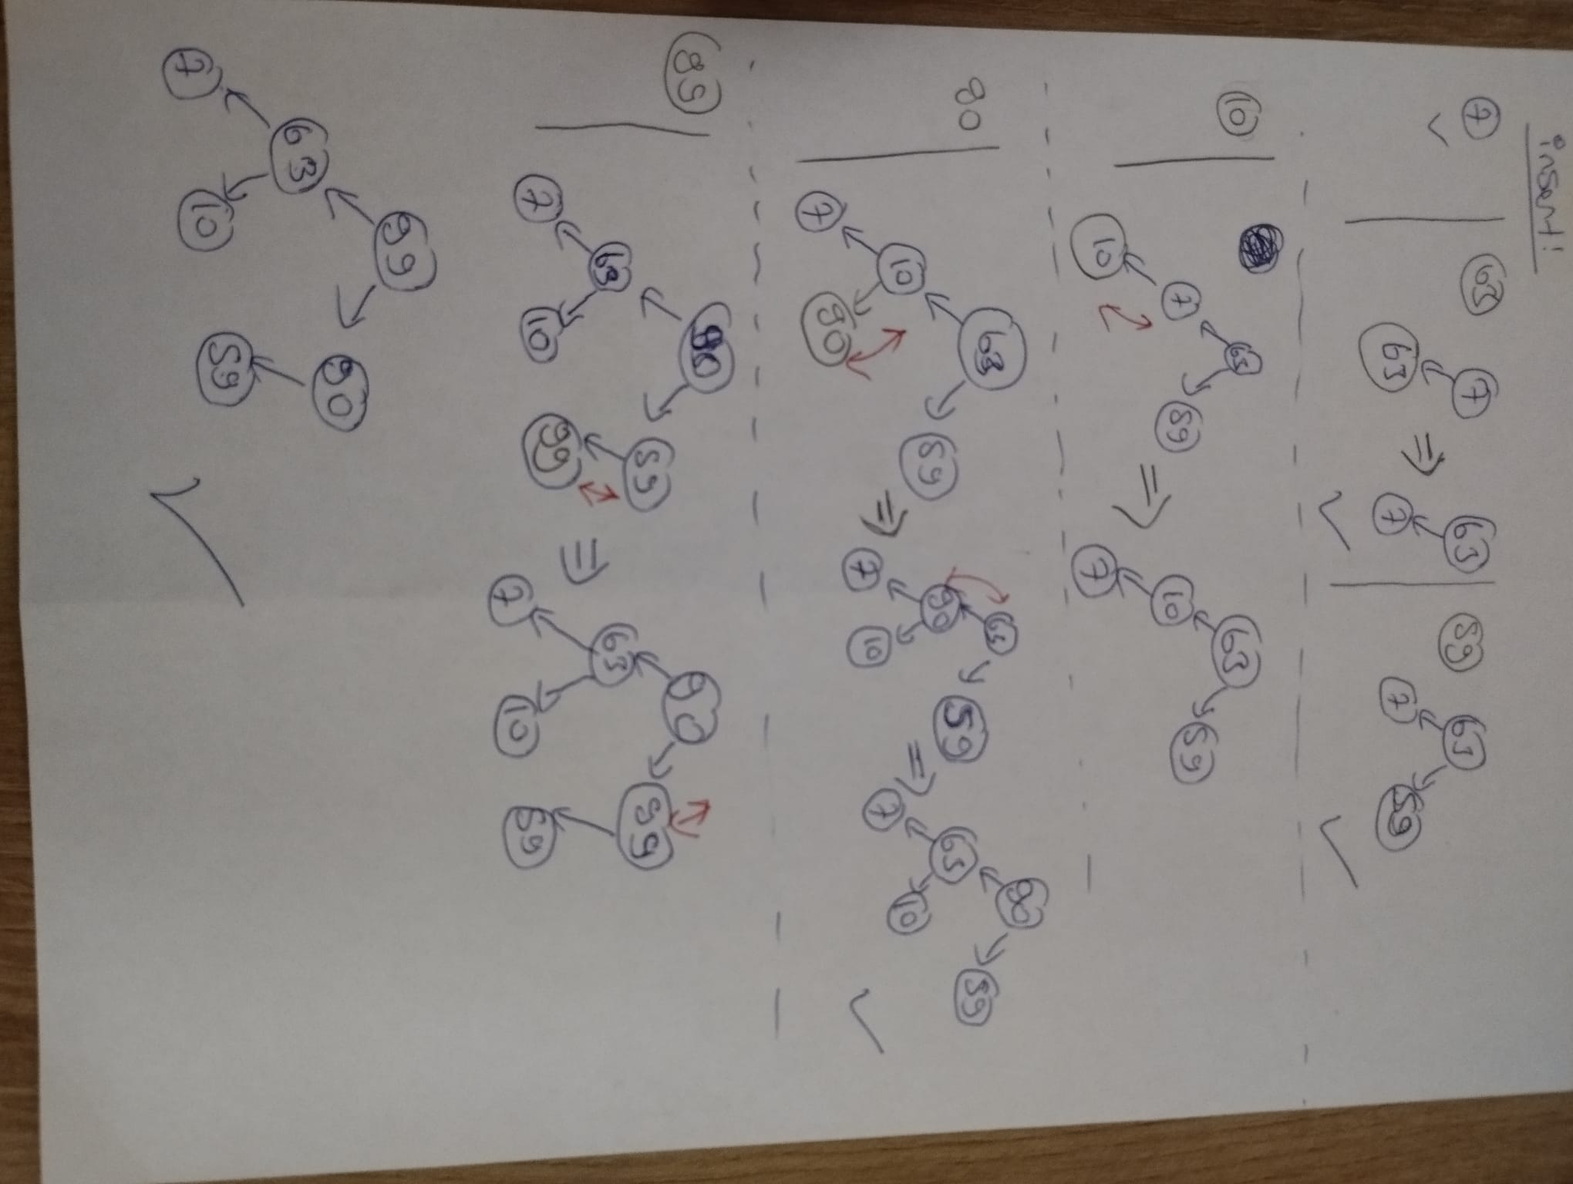

# Removing from heap

Remove one key from the heap (with the highest value for the max heap or the lowest value for the min heap). Draw a heap after completing each step during removing the key - after each change of the heap structure (e.g. replacing two keys).

Remove the remaining keys from the heap. Draw a mound after removing each of the keys.

## Heap after removing one key (draw a heap after completing each step while removing):

<place to paste a photo>

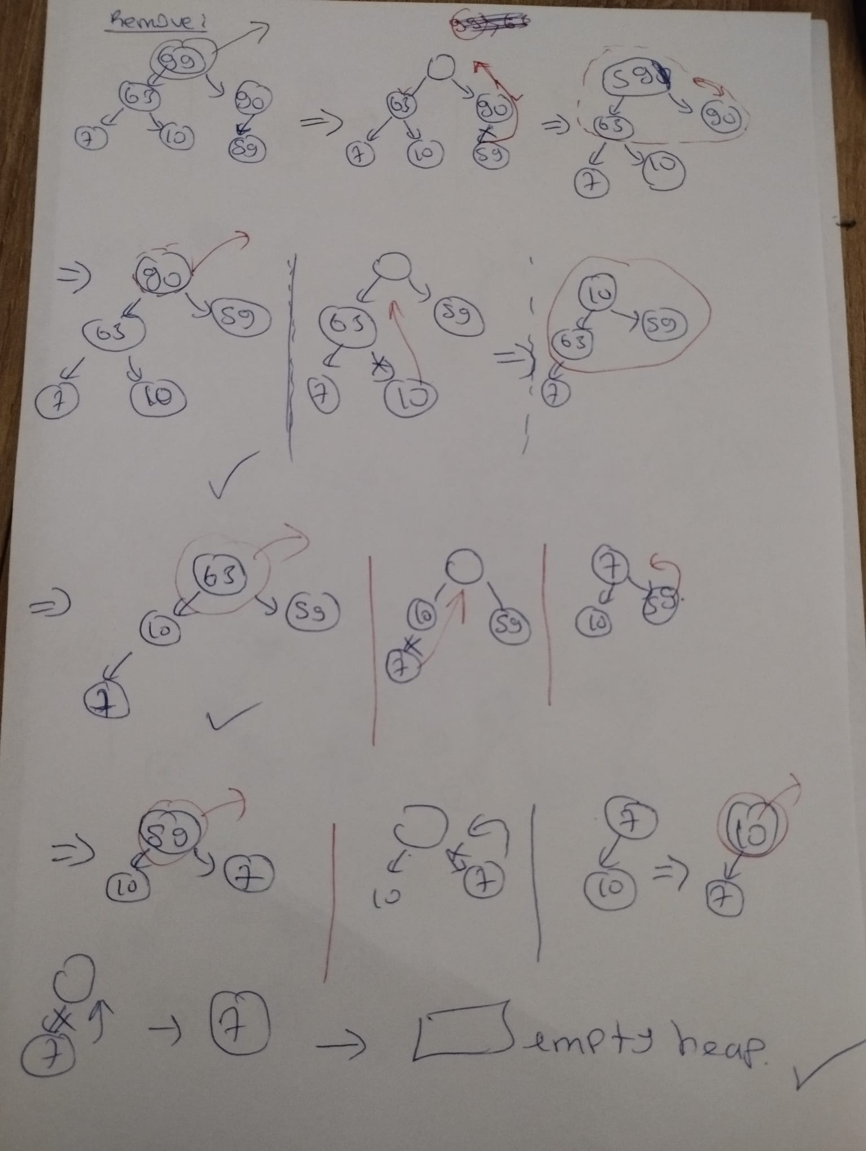

## Heap after removing remaining keys:

<place to paste a photo>

